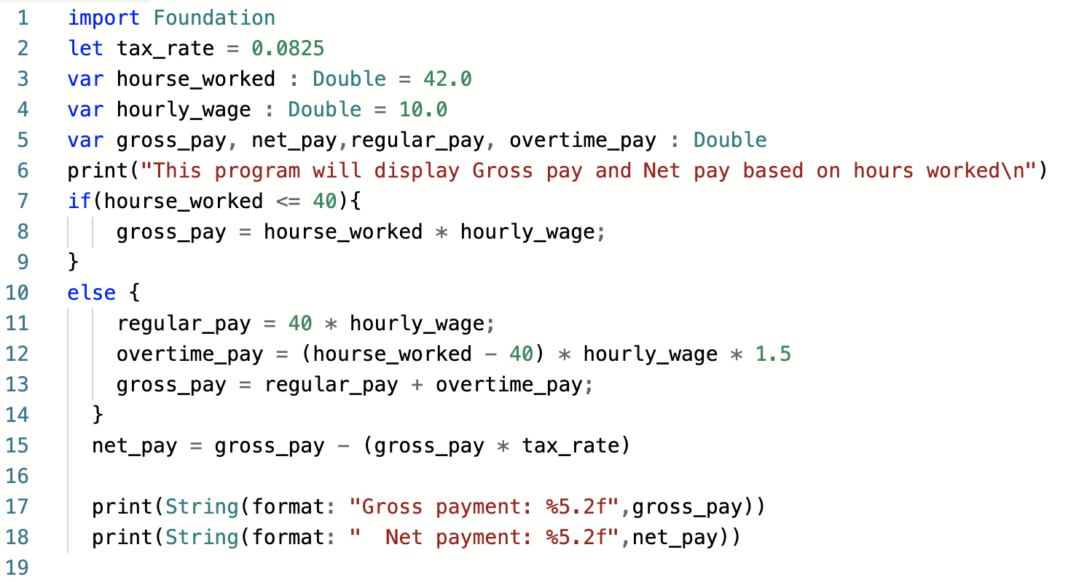

import Foundation

let tax_rate = 0.0825

var hourse_worked : Double = 42.0

var hourly_wage : Double = 10.0

var gross_pay, net_pay,regular_pay, overtime_pay : Double

print("This program will display Gross pay and Net pay based on hours worked\n")

if(hourse_worked <= 40){

gross_pay = hourse_worked * hourly_wage;

}

else {

regular_pay = 40 * hourly_wage;

overtime_pay = (hourse_worked - 40) * hourly_wage * 1.5

gross_pay = regular_pay + overtime_pay;

}

net_pay = gross_pay - (gross_pay * tax_rate)

print(String(format: "Gross payment: %5.2f",gross_pay))

print(String(format: " Net payment: %5.2f",net_pay))